ABBOTS LEIGH PARISH COUNCIL - VILLAGE HALL BOOKING FORM
Address of Village Hall:  Mr J Prodger (Caretaker)  6 Church Road  Abbots Leigh  North Somerset BS8 3QP  Tel: 01275 374597 | 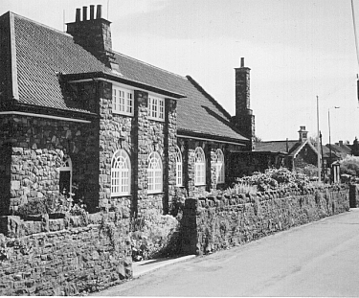
Application details – Hirer Responsible Person (if bar provided)
Name:  Address:  Mobile Phone: | Name:  Address:  Mobile Phone:
Contact details
(telephone and email)
Description of function
(please note special rates applicable for weddings and functions)
Requirement  (select as necessary) | Exclusive Use (All facilities) Hall plus kitchen facilities  Assembly Room only Committee Room
Approx. number of people attending
Date(s) required
Times required
Number of hours
(minimum 2 hours)
Hiring rate (as below)
Hiring charge
Refundable DEPOSIT for party functions (see booking conditions)
Scale of Hiring Charges  (all rates per hour) | Mon- Fri 9.00 am-11.30pm | Sat  9.00 am-11.30pm | Sun  9.00am-6.00pm
Village Hall exclusive use (all facilities) | £13.00 | £16.50 | £16.50
Village Hall (with Kitchen facilities) | £11.00 | £13.00 | £13.00
Village Hall (Assembly Room only) | £10.00 | £11.00 | £11.00
Committee Room (John Butler room) | £7.00 | £8.00 | £8.00
NOTE. For Weddings, parties and functions, minimum charges may apply.

I confirm that I have read and accept the Village Hall Booking conditions (attached) |  | Signed ....................................................  Date .......................................................
The completed application should be sent within 10 days together with payment in full to the Caretaker at the Village Hall address (cheques to be made out to ABBOTS LEIGH PARISH COUNCIL).

